Mama Air. “Breathe Safely for Your Baby”. Download Mama Air
Mama Air is personal behaviour companion, empowering mothers to navigate pregnancy safely with the air quality around them. | 
Because the air you breathe shapes the life you carry.

Why Mama Air?
Environmental risks like air pollution and heat stress can silently impact your well-being and your baby's development.
With Mama Air, you stay informed and protected - anytime, anywhere:
✅ Air pollution aware and alerts tailored to your location
✅ Personalized recommendations to reduce health risks
✅ Symptom tracking with insights designed for pregnancy
✅ Supportive advice, empowering you to make safe choices
Every mother deserves a safe environment - Mama Air helps make that possible.

Learn How It Works
Mama Air combines advanced mobile technology with intelligent cloud analytics to support your pregnancy:  - You use the Mama Air app to track your timeline, symptoms, daily exposure, and receive alerts.  - Our secure cloud platform powered by DIAQNOSTIC ** processes your data with air quality and environmental health expertise.  - You get personalized guidance on behaviour, safe movement, nutrition, supplements, work and sport loads, household and living.  That all help you avoid harmful air conditions, manage fatigue, and protect your pregnancy. | 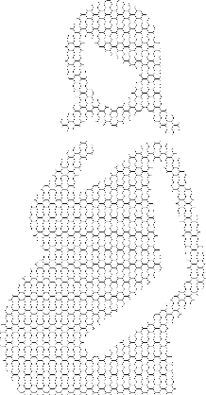

**DIAQNOSTIC analytics (https://diaqnostic.com/) is built with leading maternal health research and environmental risk detection, tailored adapted to the realities of each region of the world, local medical practice, diets and traditions.

Get Mama Air for Android
Your health breath journey starts here. Download Mama Air on your Android device.
Download Mama Air
Available for Sub-Saharan regions. iOS version coming soon.

Our Policies
We care about transparency and your peace of mind:
- Medical Disclaimer — Mama Air is a supportive recommendation tool and not a replace, but support professional medical care.
- Customer Happiness Policy — We’re committed to your satisfaction and continuous improvement.
- App Privacy Policy — Your personal and health information is handled with strict confidentiality.
- Website Privacy Policy — We respect your privacy while you browse or interact with our site.

For now, everything accessible in English. In 2025 later: French/Swahili.

Тексты privacy& policy следует взять здесь https://www.bobihealth.com/

Contact Us - We Value Your Voice
We welcome your feedback as we continuously improve our app to best support our users.
Please share your thoughts on app features or any other ideas and suggestions using the feedback form here or by sending us an email at support@mamaair.app.
Together, we create a healthier tomorrow for mothers and babies across world.

Breathe with Confidence. Act with Support. Mama Air.
Copyright 2025

